**FORM 2**

THE PATENTS ACT,

1970 (39 of 1970)

&

THE PATENTS RULES, 2003

**COMPLETE SPECIFICATION**

(See Section 10; rule 13)

TITLE OF THE INVENTION

**Magnetic pen drive**

APPLICANT

**K. RAMAKRISHNAN COLLEGE OF ENGINEERING**

**Kariyamanikam Road, Samayapuram,**

**Trichy, Tamilnadu, India– 621112**

The following specification particularly describes the invention and the manner in which it is to be performed.

**FIELD OF THE INVENTION**

The present invention relates to the field of electronic device connector plugs by magnets, which will speed up transmission, mitigate the complexity of the pen drive, and make handling it easier. And also the replacement of the magnet will help in increase the strong contact and also avoid the problem related to rusting and lose of data.

**BACKGROUND OF THE INVENTION**

In the present world, every electronic and electrical device is developing its own automation with unique properties based on new technologies,where we are moving towards wireless transmission of data. Till date we are inserting the pen drive to the port where our invention will reduce the usage of the USB ports.

Our invention will replace the connecting plugs with magnet which will help in making the contact with the laptop so that the transmission of data becomes faster and the structure of the pen drive becomes simpler.

The copper contact of the port in the laptop and the copper strap in the pen drive of our invention’s contact will help in the transmission of the data which will accelerate in the instance due to the stiff grasp introduced by the magnetic attraction between the pen drive and the laptop.

The advancement in the usual pen drive will help in reducing the damage caused due to external disturbance and reduces the damage caused due to natural phenomenon like rusting of iron which may damage the internal parts of the pen drive and connecting plugs of the pen drive which is made up of iron.

**OBJECTS OF THE INVENTION**

The object of the invention is to achieve the user’s need and reduce the time of transferring the files. Every electronic and electrical item in the modern world today is creating its own automation with specialized characteristics based on new technologies.

The object of the invention will give the durability and flexibility for the user to use the product so that it will help user to handle easily in their comfort zone.

The object of the invention will help in increasing the speed of transferring files and reducing the space for the ports.

**SUMMARY OF THE INVENTION**

**The main three features of the present invention are reducing inserting complexity,increasing the speed of transferring files and reducing the space for the ports.**

The embodiment of the present invention provides a solution to the field ofelectronic device connector plugs by magnets, which will speed up transmission, mitigate the complexity of the pen drive, and make handling it easier. And also the replacement of the magnet will help in increase the strong contact and also avoid the problem related to rusting and lose of data.

Images, movies, audio files, and other graphic files can all be stored on a magnetic pen drive, also known as a memory stick or USB stick, which is a portable electronic device. It may be easily transported to any area due to its tiny size. A flash memory chip, a crystal oscillator, a LED, a place for a second flash memory chip, a write-protect switch, and a magnet are all parts of the device. It also includes a USB mass storage managed device. The connecting plug will be replaced by a magnet, which will strengthen the connection and make the construction simpler. It will be useless to keep a side port for a USB connection.

The data is conveyed as an analogue input through the connector plug, which normally includes four port lines that link to the equivalent port lines in the electronic equipment (laptop, pc). Data loss is less likely now that the connector plug has been changed, as is the case with iron rusting. As a result, file transfers will take longer, less port space will be used, and the pen drive will last longer. The internal circuitry of the pen drive receives electricity from the computer to function. They can use the computer's built-in USB interface to connect to it.

With the use of our technology, connecting plugs will no longer be necessary because a magnet will aid make contact with the laptop, allowing for speed data transmission and a more straightforward pen drive design. As a result of the rigid grip introduced during the magnetic attraction between the pen drive and the laptop, the copper contact of the port on the laptop and the copper strap in the pen drive of our invention will help in the transmission of the data, which will become faster in the case of our invention.

We are heading towards wireless data transmission as every electronic and electrical object in the modern world develops its own automation with unique traits based on new technologies. Our invention will decrease the use of USB ports, where we currently insert the pen drive into the port.

Due to the advancement of the current pen drive already the structure of the chip that is the storing device and operating device of the circuit is modified and minimized.

In addition to that our invention or the advancement in the pen drive may held in many circumstances of transferring of data. Its compact and simpler advanced structure helps in easy handling in public sectors and increases the durability of the invention

**BRIEF DESCRIPTION OF DRAWINGS**

The following detailed description is described based on the illustrated drawings with respect to its reference numbers.

FIG 1 illustrates the systematic view of the auto mike posture adjuster cum live streamingsystem.

|  |  |
| --- | --- |
| **Reference Number** | **Indicated Component** |
| 1 | Permanent magnet |
| 2 | Metallic wire |
| 3 | Copper strip |
| 4 | Connecting port |

**DETAILED DESCRIPTION OF INVENTION**

A portable electronic device called a magnetic pen drive, often referred to as a memory stick or USB stick, is used to store various forms of data, including images, movies, audio files, and other graphic files. Due to its small size, it can be readily transported to any location. The device consists of USB mass storage controlled device, USB connector, test points, flash memory chip, crystal oscillator, LED, space for second flash memory chip, write-protect switch magnet,…We are using a magnet to replace the connector plug, which will make the connection more rigid and simplify the structure. Maintaining a side port for a USB connection will be pointless.

The connector plug typically has four port lines that connect to the corresponding port lines in the electronic device (laptop, pc), through which the data is transferred as an analog input. Since the connector plug has been changed, there is less likelihood of iron rusting and data loss. This will lengthen file transfer times, decrease the need for port space, and increase the pen drive's longevity.The computer supplies power to the pen drive's internal circuitry so it can run. They can connect to the computer using an integrated USB interface.

**Working:**

We use MOSFET in the pen drive, which is a NPN junction, the only difference is presence of two gate in the FET upper and lower respectively.The gate is separated in the presence of oxide layer through which the flow of current is absent.

Source and drain are n type silicon which has high number of electrons. With the help of tunnelling process the information get transferred to the storage. The four ports are

Green: data+

Black :GND

White: data-

Red: +5

Which get interlinked with the ports of the laptop where we are using a magnet to replace the connector plug, which will make the connection more rigid and simplify the structure.

Parts explanation

**USB Mass Storage Controller/Controller Chip**:

Where the transferred information is kept and stored, and how each type of storage varies according to its capacity.

**NAND Flash Memory Chip:**

It is non volatile, where we can edit the date which is saved for future purpose, and replace the current information, which is used to increase the primary capacity, we use electronic devices to store the data in NAND flash chip which is separated as blocks. The presence of metal oxide semiconductor, we will be able to retain the data in the absence the power

The two gates that make up NAND memory cells are the control gate and floating gates. These gates help to control the flow of data. After being placed one byte (or word) at a time in the NAND gate, the data is erased in blocks. This page goes into further depth on how a pen drive, or more specifically, a NAND flash memory chip, operates.

**Crystal Oscillator**

A tiny piece of quartz that is installed within the pen drive and vibrates at a particular frequency called the crystal oscillator. It serves as a miniature clock inside the pen drive, managing the time and operation of each component by offering precise timings.

**Switch**

If the user needs great data security, it is typically put in pen drives and is an optional component.

**Second NAND flash Memory Chip Space**

A second NAND flash memory chip can be inserted in the extra slot that is added to some pen drives during the manufacturing process to improve the pen drive's storage capacity.

**We Claim,**

Signature of Applicant

**ABSTRACT**

**Magnetic pen drive**

The present invention typically use a connection plug to enter a pen drive into the port on devices like laptops, pcs, etc. When a pen drive is not used for an extended period of time, the connection plug may rust, causing our data to be lost. Therefore, as a practical solution to this issue, we propose replacing the plug with a magnet. This will boost the pen drive’s longevity while also extending file transfer times and reducing port space requirements and complexity of construction. The connectivity will have a strong grasp according to the magnet pull.

**Most illustrative Fig 1**

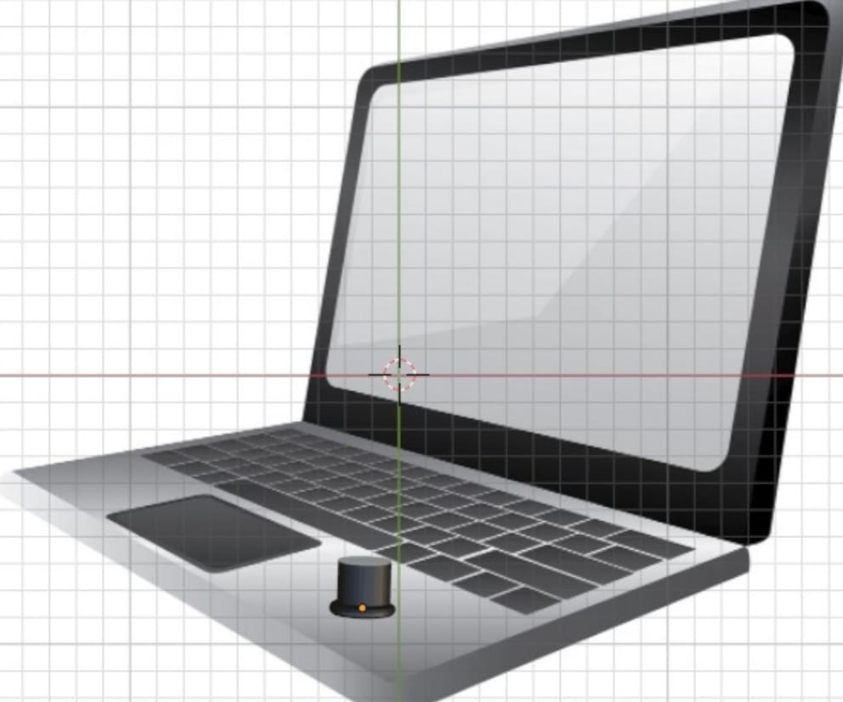

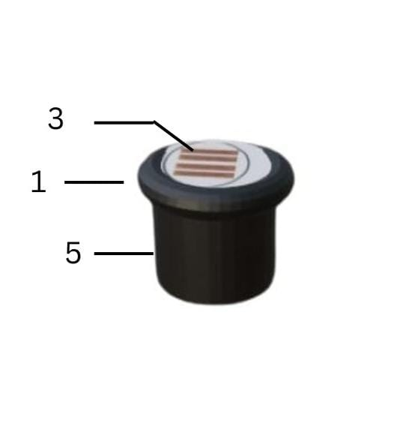

**Illustrative figure of II**

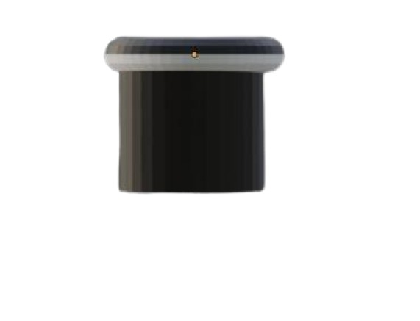

**SIDE VIEW OF THE INVENTION**

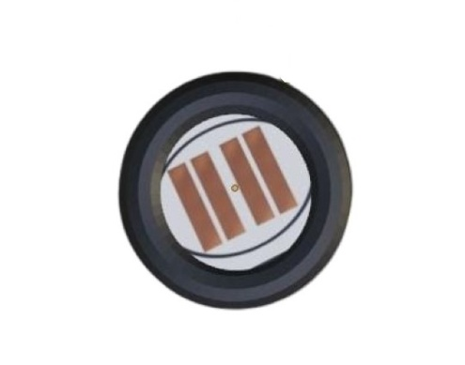

**TOP VIEW OF THE INVENTION**